Testing and User Feedback

# Playtesting

## Evidence

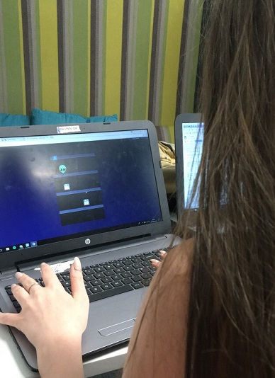

This is a picture of a playtester playing my game.

# User feedback and analysis

## Playtest feedback

I received feedback that the most important feature that needed to be implemented was adding the capability for three people to play the game simultaneously.

Out of the features I offered the testers to rate the importance of, I realised that the most important element I needed to add to my game was Player to Player collision and that secondly, more complex object movement was a concern of players.

## Game optimisation

As the above features were the most important to players, I implemented another two players as shown below:

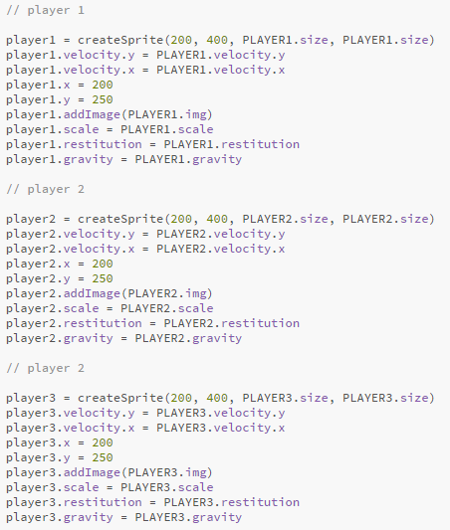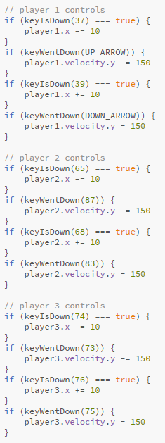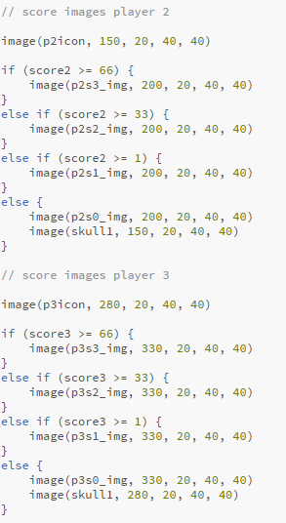

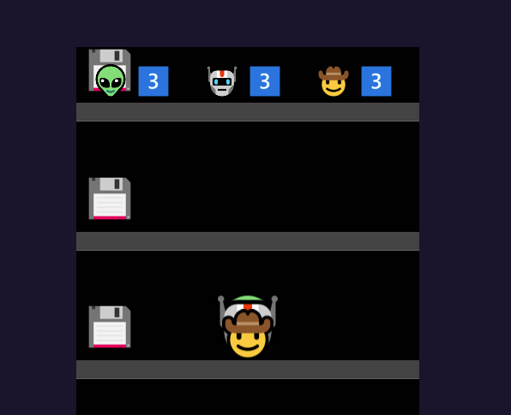

Here you can see that I have implemented two more players and they have a score, they do not currently have collision rules as this is complex and due to the nature of the movement in my game this is a difficult task.